17393653

Open source

Task1:

Research:

Introduction

The following research is based on three existing fitness apps that are available on the android operating system Google playstore. In the research below The apps that I have chosen are namely runkeeper, workit and sworkit.

Runkeeper:

Overview of the app:

The Runkeeper app for Android is an app geared towards runners, walkers, and hikers. Like the other top running-based Android apps, RunKeeper takes advantage of the GPS features built into your Android smartphone. With route tracking, a great history feature, and a few other personalization features, RunKeeper can hold its own against the pack. The overview of the application also includes:

* Has weight tracking:
* Syncs to the cloud:
* Tracks distance:
* Has coaching:
* Integrates with social networks:
* Counts how many calories you have burnt:
* Measures pace:
* Has social features:

Strengths and weakness of the app:

**Strengths:**

* Highly accurate tracking
* Easy to use
* Syncs with Pebble, Fitbit and other fitness devices
* Includes Apple Watch app
* Application tracks runs perfectly, current pace, time and enable users to see areas to improve in advance.

**Weakness:**

* In-app purchases are pricey
* Application freezing while navigating within the app.
* Application crashes when user is trying to enter an activity or weight manually.

Innovative features of the app:

Runkeeper will show your route on a detailed map. More than just your route, however, Runkeeper will tell you your pace, average and top speeds, distance and time. A great feature the Runkeeper includes is the ability to view your route map while still engaged in your workout. For hikers, this feature can be invaluable if you ever venture off the beaten path. The innovative features also include:

* Running Bunches - Make a custom challenge, welcome companions, track each other’s advance, and utilize the chat to cheer each other on.
* Sound Prompts - A persuading voice that the user can customize to transfer his pace, separate, and time.
* Preparing Plans - Make major advance by taking after arranging.
* Courses - Spare, find, and construct unused courses with GPS.
* Challenges - Remain spurred with select workout encounters and rewards.

Screenshots of the app:

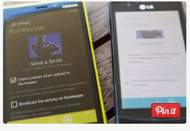 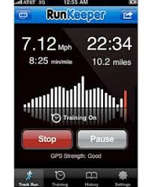

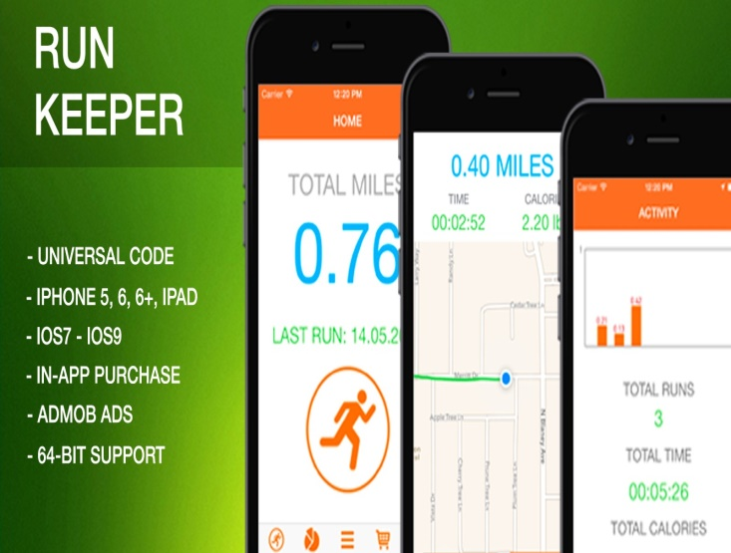

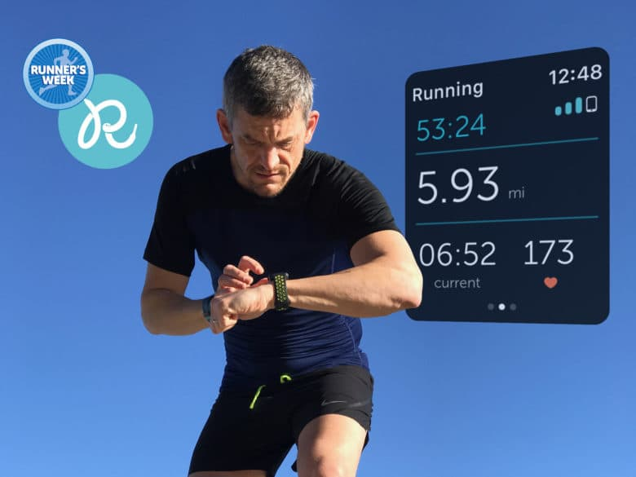

Workit:

Overview of the app:

WorkIt is an app to help people working in hourly jobs get answers to questions about workplace policies and rights from trusted and trained peer advisors. WorkIt also connects you to coworkers who share your experiences and can provide support and care.

Strength and weakness of the app:

Innovative features of the app:

* Creates unlimited workout routines.
* Creates cardio workouts, body weight workouts, and lifting workouts or mix-and-match.
* Workit makes it simple to edit and organize your workout routines.
* Creates workout routines for each day of the week by setting training days.
* Get the bodyweight tracker from the feature store
* Log your bodyweight, body fat, and other body stats
* Automatic BMI calculation
* Bodyweight progress graphs
* Take progress pics

Screenshots of the app:

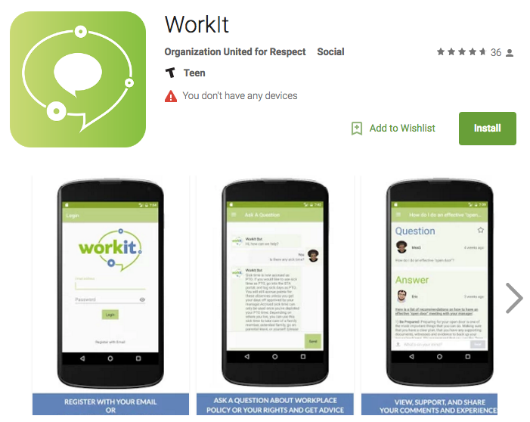

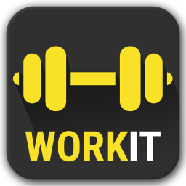

Sworkit:

Overview of the app:

This app is impressive, but how does it stand up when compared to other Android fitness apps?

A Detailed Summary of Your Workout

Innovative features of the app;

Like all apps that use the built-in GPS feature on Android phones, you need to have a clear view of the sky in order for the tracking to work. So while Runkeeper can function like a much more expensive stand-alone GPS tracking device, don't expect it to work when you are hiking in the deep woods. The last thing you want is to go hiking off-path and not have your GPS working to guide you back.

Settings and Personalization in Runkeeper

Running-based apps like Runkeeper, Cardio Trainer, and RunTastic all allow varying levels of personalization. With Runkeeper, you set how you want your workout to be recorded, choosing either distance or time. You also choose whether to use miles or kilometers. Unlike Cardio Trainer, however, Runkeeper does not give you total calories burned summary, nor does it provide details on your altitude covered like RunTastic can.

The main setting features are how you want (or don't want) Runkeeper to share your workouts with social networking sites like Facebook and Twitter. If you are part of a fitness group that relies on social networking sites to share your workouts or competes against other members, Runkeeper provides effortless uploading and will even post your route on Facebook if you choose.

If you're not a fan of social networking, these features and personalization settings of Runkeeper will be a bit lost on you.

Mapping and History

In the B.A. days (that's "Before Android,") runners who wanted to keep track of their workouts had to rely on pen and paper or a computer. With apps like Run Keeper, not only can you get a wonderful and easy to view map of your route, but the app will automatically save each workout to its "History" section. There, you can review the details of your workout and compare workouts against each other.

Summary of the Runkeeper Android App

If Runkeeper is the only running-based app that you'll ever try, you will be impressed by its mapping features and social networking capabilities. If you are installing a few running-based apps and Runkeeper is just one of them, you'll find things you like and things you wish it included.

Runkeeper is useful, easy to use and feature-rich enough to list as one of the top running apps for Android. It is not, however, so feature-rich that it does the running for you.

Work it - Workout with WORKIT! A Top rated workout tracker and personal trainer for android. Build muscle, get in shape, and improve your overall fitness with WORKIT the best personal trainer and workout tracker app for you!

On the Go

Once you start your run, Runkeeper displays your distance and pace in large, easy-to-read numbers. Time, average time, and calories are also displayed. Swipe to the right and you’ll see your mile splits. The app also gives you customizable audio prompts that tell you time and distance every five minutes or every mile. If you find the prompts annoying, you can turn them off altogether.

When your run is over, you can share it on social media, discard it or save it to your history. That’s another benefit to Runkeeper—it doubles as a running log, saving all your data for each workout. The app displays each run in a list format. You can use an in-app purchase to sign up for an account at Runkeeper.com to get cumulative totals and more analysis. You can also view any of your runs on a map.

In App Purchases

FitnessKeeper offers several levels of personal training as in-app purchases, beginning with Runkeeper Go and moving on to 4K and marathon training specialty programs. As a result, the app is popular with professional and dedicated runners. Runkeeper Go subscribers receive new workouts each week, tailored to meet their goals and schedule. A Runkeeper Go subscription adds weather insights, live tracking, progress reports and in-depth comparison of workouts to your app.

Workout with WORKIT! A Top rated workout tracker and personal trainer for android. Build muscle, get in shape, and improve your overall fitness with WORKIT the best personal trainer and workout tracker app for you!

**New Premium Features Include Bodyweight Tracker and more!***

-

Workout Tracker

WORKIT is a simple to use workout tracker for your weightlifting and cardio training. Use the app for your gym workouts or home workouts. Perform your daily routine and record each exercise with a simple tap of a button. WORKIT will keep detailed fitness logs of your training and provide personal progress graphs and statistics.

Personal Trainer

WORKIT will be your personal trainer for gym workouts or home workouts with descriptions and animations to improve your training.

Workouts

-Create unlimited workout routines!

-Create cardio workouts, body weight workouts, and lifting workouts or mix-and-match

-Simple to edit and organize your workout routines

-Create workout routines for each day of the week by setting training days

Exercises

-Many muscle building exercises including gym workout machines, dumbbell exercises, barbell exercises and more!

-Many cardio exercises including walking, running, swimming, yoga, and more!

-Create your own exercises

-Log exercise notes

-Rest timer for cardio exercises and weightlifting exercises

-Stopwatch for cardio exercises and weightlifting exercises

-Weight Plate Racking Calculator

Workout Programs

-Find the best workout program for you

-Default workout programs for beginners, intermediate, and advanced bodybuilders

-Programs include Stronglifts, Starting Strength, P.H.U.L, P.H.A.T, PPL, and more!

-Create and organize your own workout programs

Workout Log

-Track weight and reps by adding each set to your workout log.

-Track time, distance, and calories burned for each cardio fitness session in your workout log.

-View your daily workout logs on the calendar.

-Export your workout logs as a spreadsheet (.csv) file to the Google Drive cloud or device storage.

Fitness Statistics

-Track weightlifting statistics such as maximum and average reps, maximum and average weight etc.

-Track your cardio fitness statistics such as time, distance, calories burned etc.

-Progress graphs for all exercises

-Donut charts of your most worked muscles and body parts

-Track data for number of workouts, number of reps, most performed exercise and more!

-One Rep Max calculations to improve your strength

Backup and Restore

-Be sure that none of your training goes to waste!

-Backup and restore all your routines, training data, and custom exercises to the Google Drive cloud or device storage.

Sworkit

Tell Sworkit the type of workout you’re looking for (strength, cardio, yoga, or stretching) and the amount of time you’ve got to do it (anywhere from five minutes to an hour), and the app delivers moves to follow during your sweat session.

Choose to upgrade and the app will enable you to customise your workouts by setting the number of reps and the areas of the body you want to focus on.

It’s a simple system that offers great workouts for those already armed with knowledge of the areas they want to target.

Over 25 million people use Sworkit because it's the smartest workout app on the planet. You choose what kind of workout you want and how long you have, then Sworkit will show you exactly what to do. No more needing a gym, or weights, or excuses, just Sworkit.

Is it legit?

Yes, we were rated #1 by a recent study assessing fitness apps based on the parameters for safety, stretching, progression, and more set by the ACSM (American College of Sports Medicine). We've delivered over 50 millions workouts to people of all fitness levels.

What can we do for you?

• Get you started on a 6 week program to get "Leaner," "Fitter," or "Stronger." We have plans for beginners, intermediate, and advanced.

• Give you a huge database of body weight exercises. That means you can do these workouts from anywhere. No more travel or too busy excuses. You can even do a 5 minute stretch in the office.

• Provide the ability to make your own custom workout. That means you can make a workout with all of your favorite exercises, nothing you despise. Hello, motivation!

Who is this app made for?

We made this app with the whole purpose to be for anyone who needs an easy solution for fitness, without the complicated exercises and overpriced guidance, we encourage everyone to find what they love in the app and thrive. So that means it's for you, your family, your friends, your teacher, your boss. It's for the traveler that needs energy, the new mom who can't make too much noise, and the dad who is realizing the dad-bod fad went out of style way too fast.

We also serve as a solution for Health + Wellness coaches. That's how awesome it is.

• Personal trainers

• Sports trainers

• Physical therapists

• PE teachers and more.

-------------------------------------------------------

Here are all the benefits of Sworkit that help you get in shape faster and more reliably than ever.

• Guided workout plans

• 200+ workouts and exercises

• Custom exercise intervals (H.I.I.T + Tabata)

• Unlimited custom workouts

• Ask a Trainer access

• Access to our Web App

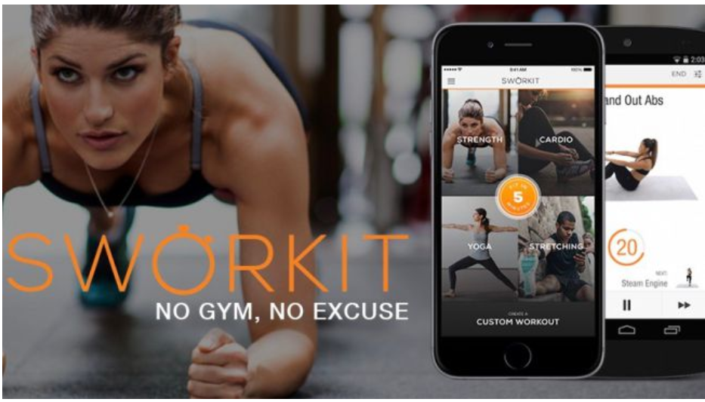

Comparison of all three apps:

The difference between all the three apps above is that

List of the best features of all the apps:

Conclusion:

References:

Lifewire. (2019). How Does Runkeeper Compare to Other Fitness Apps? [online] Available at: https://www.lifewire.com/runkeeper-app-android-1616866 [Accessed 20 Mar. 2019].

Google.co.za. (2019). runkeeper fitness apps - Google Search. [online] Available at: https://www.google.co.za/search?q=runkeeper+fitness+apps&rlz=1C1GCEU_enZA828ZA828&source=lnms&tbm=isch&sa=X&ved=0ahUKEwif2dqW0JDhAhX1TxUIHd1cADwQ_AUIDygC&biw=987&bih=855#imgrc=AW6rQnOKIp36OM: [Accessed 20 Mar. 2019].

Play.google.com. (2019). [online] Available at: https://play.google.com/store/apps/details?id=sworkitapp.sworkit.com [Accessed 20 Mar. 2019].

Google.co.za. (2019). fitness apps for android - Google Search. [online] Available at: https://www.google.co.za/search?q=fitness+apps+for+android&rlz=1C1GCEU_enZA828ZA828&source=lnms&sa=X&ved=0ahUKEwjOhc-u2JDhAhXwx4UKHV8rBhwQ_AUICSgA&biw=1192&bih=855&dpr=1 [Accessed 20 Mar. 2019].

Design:

Introduction: